What are systemd and systemctl (Simple Explanation)
systemd (the brain): The manager that controls everything running in Linux
Responsible for:
Starting services during boot
Managing background services (daemons)
Handling system states (like shutdown, reboot)
It is one of the first major components started during boot, and it is responsible for bringing up and supervising background programs called services.

systemctl (the controller): The remote control to manage services
It is the command-line tool used to interact with systemd

Check Service Status (ssh): If we want to check if ssh is running. You will see the below.
Key Output Fields:
Loaded: Service file is present.
Active: active (running) means it is working.
The status output combines several useful ideas in one place: whether the service definition exists, whether the service is currently active, and often the most recent log messages connected to that service.
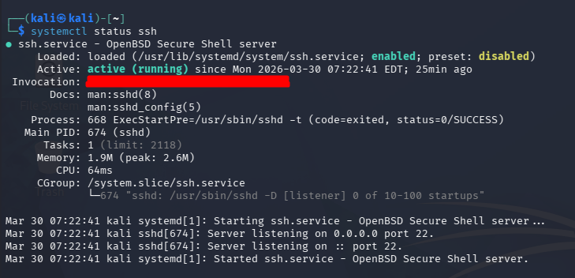
We can filter active status using grep
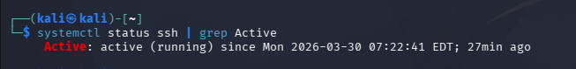
See what happens if a service does not exist. Say I wanted to check the status of a fake-service
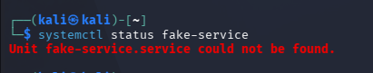
This error means the service name is wrong or the software is not installed.
Summary:
- Learned how to check if a service (ssh) is working or not using systemctl status ssh
- Learned that Active status is the green light showing everything is okay.
- We used grep to filter detailed report
- "Unit could not be found" means the service does not exist or is misspelled.

START, STOP and RESTART
Services need to be managed across their lifecycle. A service may be installed on disk, but that does not automatically mean it is currently running. A process is a running instance of a program, while a service is the managed unit that tells systemd how that program should be started, stopped, restarted, and supervised.
Stop Service (systemctl stop)

Check the status after stop
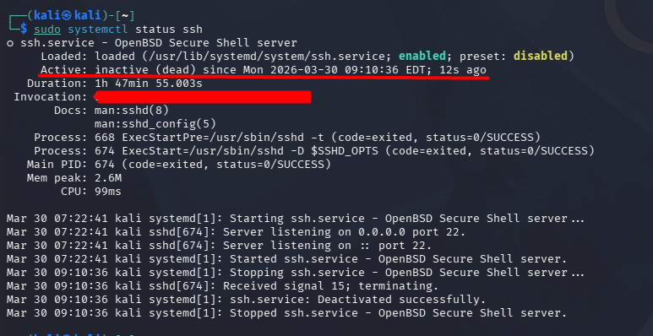
It should say Active: inactive (dead). That means the service definition still exists, but the program is not currently running.
Start Service (systemctl start): Start the service and verify the status
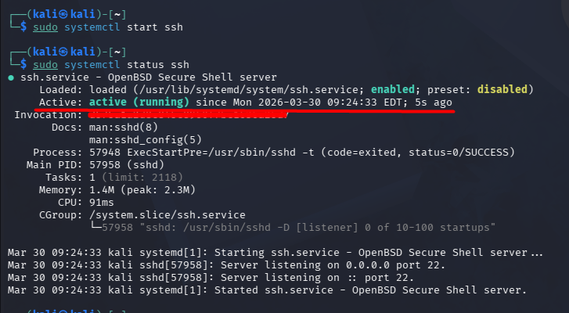
Verify the service:
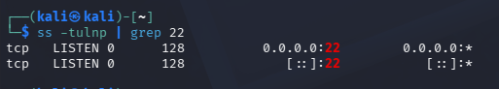
Quick health check:

Check Logs:
Sudo journalctl -u ssh -n 20
Look for Errors, Failed logs etc
Verification Flow: Restart → Status → Port → Connect → Logs

Restart Service (systemctl restart):
We will restart the service and check the status. Notice the new PID which means that service is been stopped and restarted. 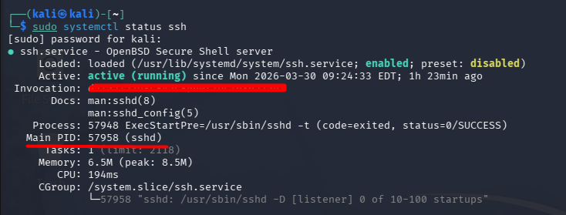
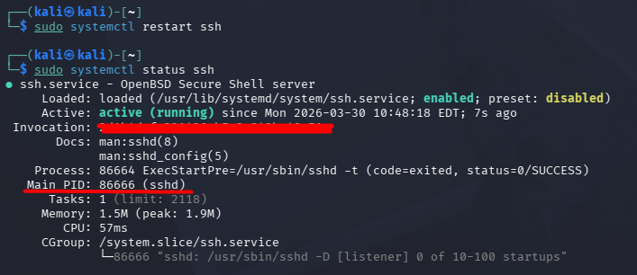

Summary:
We learned how to manage the lifecycle of your Linux services.
- stop: Sends the service on vacation (Status: inactive).
- start: Brings the service back to work (Status: active).
- restart: Refreshes the service completely, giving it a new Process ID (PID)

Services can be set to start automatically when the computer turns on. We often confuse start/stop with enable/disable. They are related, but they answer different questions:
- Enable: Start at boot.
- Disable: Do not start at boot.
Here I learned about "Autostart List" for your Linux services.
- is-enabled: Checks if a service defaults to ON or OFF at boot.
- disable: Removes a service from startup (but keeps it running now).
- enable: Adds a service to startup (so it survives a reboot).
This functionality is critical for servers, as you want important services (like Web Servers or Databases) to come back online automatically if the server restarts for any reason.

Reloading configuration without downtime
Some services can update their configuration without fully stopping. This is valuable because it reduces or avoids downtime.
- Restart: Stop and Start (Disruptive, PID changes).
- Reload: Read new config while running (Zero downtime, PID stays same).
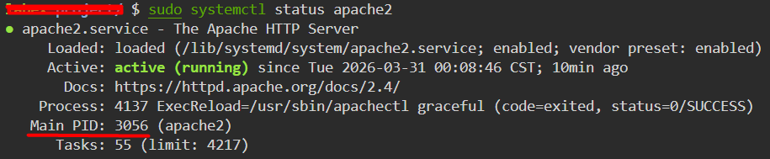
Edit config file. Reload service and verify PID
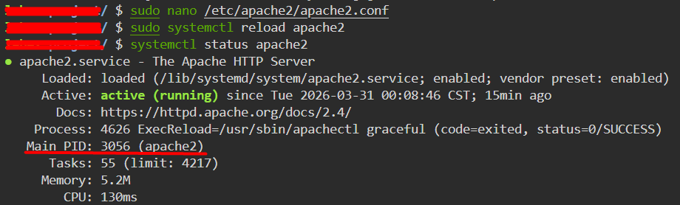
Compare the Main PID:
- Same as before? Success! Zero downtime reload.
- Different? It restarted instead of reloading.
Summary: I learned the professional way to update services.
restart: Easy, but causes a brief outage and changes the PID.
reload: Smarter. Keeps the service running (Same PID) while applying changes.
Always try to use reload first when updating configuration files on a live server!

View Service Filtered Logs
Analyzed SSH logs using journalctl to track connection, authentication, and session activity.
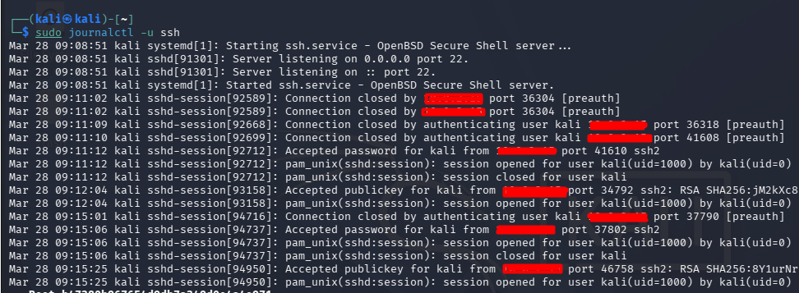
Follow Logs (Real-time)
Watch the logs live as they happen using -f (follow). This is similar in spirit to tail -f, but it works against the systemd journal instead of a plain text file.
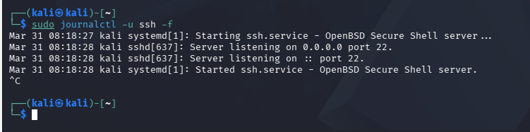
Trigger Log Events: We can open two terminals in one we can use journalctl -u ssh -f to check the live events and in another restart the service following the command systemctl restart ssh
This is what I learned: The experts debug servers: they watch the logs in one window while testing their fixes in another!
Broken service rescue
Scenario: The monitoring dashboard is red. Apache2 is down.
Goal: Diagnose, Repair, and Restore the service.
Your Mission:
- Investigate: Check status (systemctl status).
- Analyze: Find the error in logs (journalctl).
- Repair: Fix the config file (nano).
- Recover: Start the service (systemctl restart).

We checked the system using status command, saw status as failed > Checked the logs using journal > saw the error as “Invalid command 'RubbishDirective', perhaps misspelled or defined by a module not included in the server configuration” > Edited the config file and saved it > restarted the service and checked the status showing us Status as ACTIVE
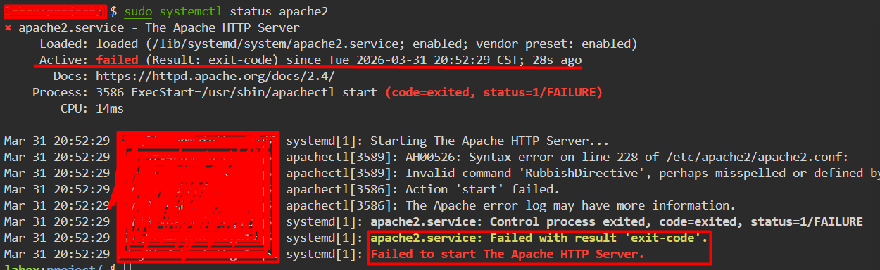

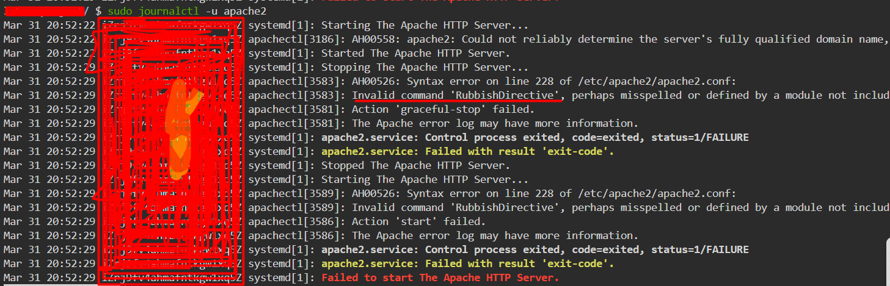

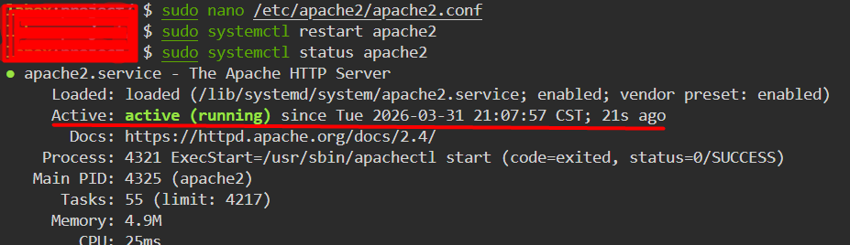

Standard Logs Location:
Logs are records of system events. They are one of the main ways Linux systems explain what happened in the past.
This is why logs matter so much in operations and security work. If a login failed, a service crashed, or a configuration change broke something, the log is often the first place you look.
Explore log Directory: log lives in /var/log
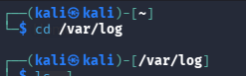
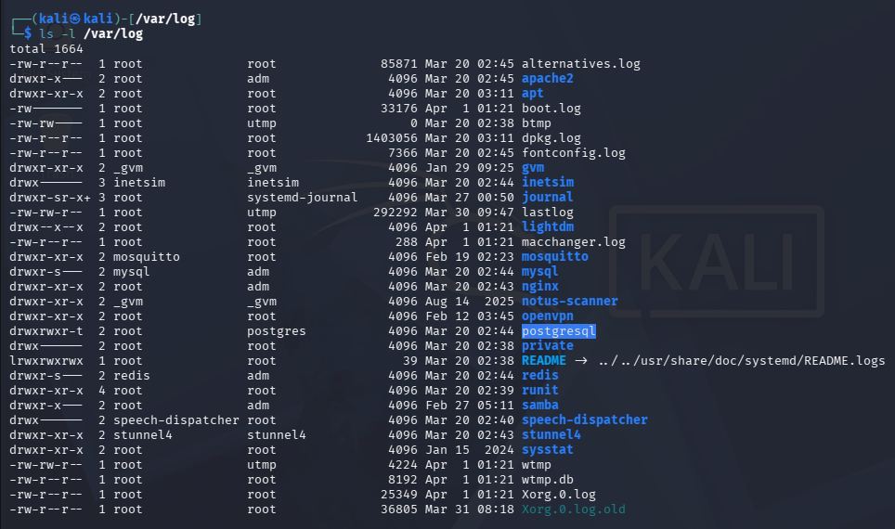
Key Logs:
syslog: General messages.
auth.log: Authentication/Security.
dmesg: Boot messages
View syslog:
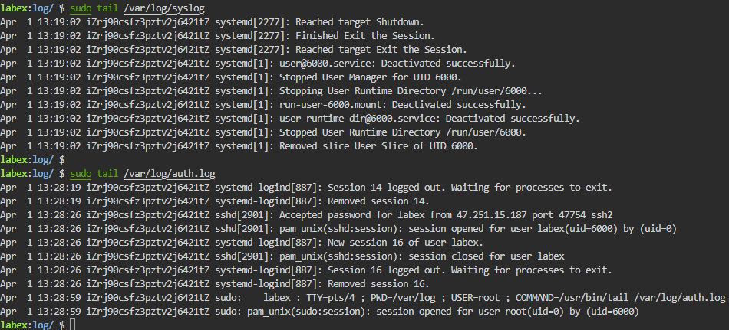
Records logins, sudo usage, and authentication errors. This file is especially important during troubleshooting and incident investigation.
What to look for:

Successful logins.
Failed login attempts ("Invalid user").
sudo commands executed by users

Monitoring logs in Realtime
Real-time monitoring lets you watch new log events as they happen instead of reading history afterward.
In Linux, tail -f (follow) lets you watch a text log file as new lines are appended to it. This is one of the most common troubleshooting techniques on Linux because it turns logs from static evidence into a live stream of behavior.
In this lab, you will:
- Watch the security log (auth.log) in one terminal.
- Trigger a security event (e.g., using sudo) in another.
- See the event appear instantly.
